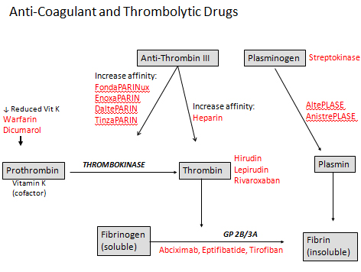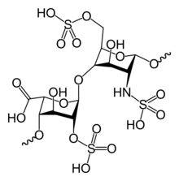Heparin



|  |  |  |
| --- | --- | --- |
| **Inactive Factor: Synonym** | **Active Factor: Synonym** | **Half-Life** |
| I: Fibrinogen | Ia: Fibrin | 3-4 days |
| II: Prothrombin | IIa: Thrombin | 100 hours, longest |
| VII: Stable Factor | VIIa | 3-6 hours, shortest |
| IX: Platelet Cofactor II | IXa | 15-24 hours |
| X: Stuart-Prower | Xa | 40 hours |

Clots:

1. 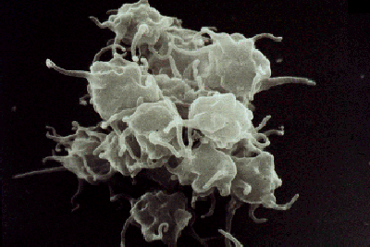Thrombus clot
   1. Arterial thrombus Platelet rich (white clot) 🡪 lead to endothelial damage (hear attack)
   2. Venous thrombus Erythrocyte and fibrin rich (red clot) 🡪 venous stasis (slow flow)
2. Embolus detached

Unfractionated Heparin (UFH) 🡪 Indirect 🡪 Treat thromboembolism (prevent clot)

1. Treat: anticoagulant in patients with renal problems
2. PK: short half-life (0.5 – 2 hr) 🡪 unpredictable dose response (monitor)
3. Dosing: Weight
   1. 80 units/kg IV **Push** immediately then with
   2. 18 units/kg IV
4. HIT: Heparin Induced Thrombocytopenia
   1. Type 1 HIT benign
   2. Type 2 HIT immune mediated process
      1. IgG antibodies
5. Overdose reversal: 1mg protamine (from fish sperm) reverses 100 units

Low Molecular Weight Heparin (LMWH) Indirect 🡪 prevent clot

1. Treat: anticoagulant in pregnant patients (does not cross placenta)
2. PK: long half life (4-5 hr) 🡪 easier to monitor than Heparin
3. Advantage
   1. Use at home
   2. Less protein binding
   3. Lower risk of HIT and osteoporosis

|  |  |
| --- | --- |
| Agents | Treatment Doses for DVT/Pulmonary Embolism |
| Enoxaparin  (Lovenox®) | CrCl > 30 ml/min: 1 mg/kg SQ Q12  1.5 mg/kg SQ daily  CrCl 10-29 ml/min:1 mg/kg SQ daily  <10 (end-stage renal): use unfractionated heaprin |
| Dalteparin  (Fragmin®) | CrCl > 30 ml/min: 200 IU/kg SQ daily |
| Tinzaparin  (Innohep®) | CrCl > 30 ml/min: 175 IU/kg SQ daily |

Pentasaccharides (Indraparinux) Indirect 🡪 prevent clot

1. New anticoagulant
2. Benefits
   1. No HIT nor osteoporosis
   2. QD dosing
3. Limitations:
   1. Renal
   2. No antidote

|  |  |  |
| --- | --- | --- |
| Indication | Actual Body weight | Dose* |
| Treatment of DVT and/or PE | < 50 Kg | 5 mg SQ daily |
| 50-100 kg | 7.5 mg SQ daily |
| > 100 kg | 10 mg SQ daily |

Direct Thrombin Inhibitors

1. Use: In patients with HIT (Heparin-induced_thrombocytopenia)
2. MOA: inhibit IIa w/o use of AT (from leech saliva)
3. Drugs: -RUDIN
   1. Argatroban
   2. Lepirudin
   3. Bivalirudin

Oral Direct Thrombin Inhibitors 🡪 Dabigatran

1. Use: Patients with atrial fibrillation
2. Benefits
   1. At home 🡪 Long haf life
3. Limitation
   1. Renal clearance 🡪 kidney problems
   2. $$$

Warfarin (prevents vit K) (Direct)

1. Prevents carboxylation (activation) of Vit K clotting factors
   1. Vit K 🡪 delay onset, delay discontinuation
      1. Treat OD: Vitamin K (lowest possible dose b/c stay in system 🡪 oil soluble ADEK)
2. 3 rules of 5
   1. 5 days to take action
   2. 5 mg/day
   3. 5 days to wash out
3. ADR
   1. Necrosis:
      1. Purple toe syndrome

|  |  |  |
| --- | --- | --- |
| Drugs that Increase INR(increased plasma warfarin🡪 should reduce warfarin dose) | Drugs that Decrease INR (decreased plasma warfarin🡪 should increase dose) | Increased Risk of Bleeding (No Effect on INR) |
| **Increase catabolism of clotting factors**  *T****hyroid hormones***  **Inhibition of metabolism**  ***Amiodarone, Cimetidine, Sertraline,***  ***Ethanol (acute), fluvastatin, Fluconazole, Metronidazole, Erythromycins, isoniazid Sulfonamides, Quinolones, Macrolides***  ***(CYP2C9 and 3A4 inhibitors as in statin)*** | **Increased synthesis of clotting factors**  ***Propylthiouracil, Vitamin K***  **Induction of metabolism**  ***Barbiturates****,* ***Rifampin***  ***Carbamazepine****,*  ***Ethanol (chronic)***      **Decreased absorption**  ***Cholestyramine****,* ***Colestipol*** | ***Antiplatelet agents***  ***Aspirin, NSAIDs, Gingko Biloba, Garlic, High doses of Vitamin C and E*** |